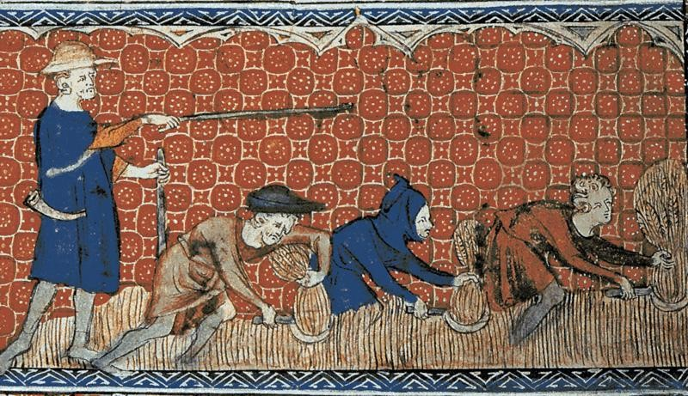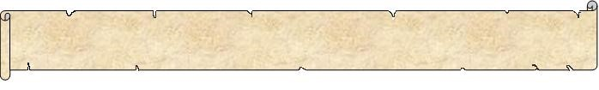
F
e
u
d
a
l
i
s
m

&

M
e
d
i
e
v
a
l

L
i
f
e

The Feudal System was introduced to
England following the invasion and
conque
st of the
island

by William the
Conqueror
.

The
Feudal S
ystem had been used in
France by the Normans from the time they
fi
rst settled ther
e around

900

AD
. It was a
simple, but effective system

for the control
of society by the King. All la
nd was owned
by the King, and o
ne quarter was kept by
as his personal property. S
ome
land
was
given
to the Catholic
Churc
h

and the rest
was leased out to others under strict controls. This means that others paid the king to use the land since he owned it. Land given to others was known as a fief.
The King was in complete control under the Feudal System. He owned all the land in the country and decided who he would grant a fief to. He therefore only allowed those men he could trust to lease land from him.
However, before they were given any land they had to swear an oath to remain faithful to the King. This was done at a formal and symbolic ceremony which was composed of the two-part act of loyalty and oath of fealty. The man receiving the fief then became a vassal of the king.
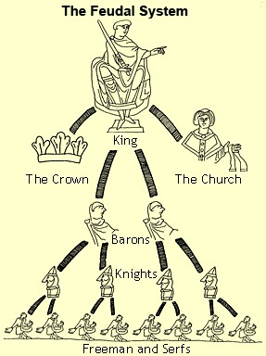
Vassals who leased land from the King were sometimes known as Barons and were generally wealthy and powerful. The fiefs that Barons were granted by the King were governed by the manor system. The vassal was known as the Lord of the Manor and established his own system of justice, minted money and set up taxes. In return for the land they had been given by the King, the Barons had to serve on the royal council, pay rent and provide the King with Knights for military service when he demanded it. They also had to provide lodging and food for the King and his court when they traveled around the country. The Barons kept as much of their land as they wished for their own use, then divided the rest among their Knights. Barons were very rich.
Knights were given land by a Baron in return for military service and also had to protect the Baron, his family, and the Manor from attack. The Knights kept land for their own personal use and distributed the rest to peasants or serfs. Although not as rich as the Barons, Knights were quite wealthy
The serfs who were given land by Knights had to provide free labor,
food and service when the knight demanded it and had no rights. The serfs were not allowed to leave the Manor and even had to ask their Lord's permission before they could marry.
Name _____________________________________
Feudalism & Medieval Life

Directions: After reading the passage, answer each question in a complete sentence or select the best answer.
- What made the Feudal System an effective system for controlling society?

- What was land called that was given out by the king?
  - A vassal
  - A fief
  - A serf
  - A Baron

- What duties did Barons have to provide in return for the land they were granted?

- What is another name for a vassal of the king?
  - Lord of the Manor
  - Serf
  - Fief
  - Knight

- What role did knights play in the manor system?

- What did serfs get in return for their labour?

- Why do you think vassals had to swear an oath to remain faithful to the King?

- Which group do you think would most want to end the Feudal System and why?

Name _____Answer Key ______ Feudalism & Medieval Life
Directions: After reading the passage, answer each question in a complete sentence or select the best answer.
- What made the Feudal System an effective system for controlling society?

The system was effective because the King was able to control all of the land in his kingdom and had the loyalty of his barons and knights because he granted them land.

- What was land called that as given out by the king?
  - A vassal
  - A fief
  - A serf
  - A Baron

- What duties did Barons have to provide in return for the land they were granted?

The Baron had to serve on the royal council, pay rent and provide the King with Knights for military service when he demanded it. They also had to provide lodging and food for the King and his court when they traveled around the country.

- What is another name for a vassal of the king?
  - Lord of the Manor
  - Serf
  - Fief
  - Knight

- What role did knights play in the manor system?

The Knight provided protection to the Lord of the Manor, his family, and the manor.

- What did serfs get in return for their labor?

In return for their labor and providing food to the Knight, they received his protection against foreign invaders.

- Why do you think vassals had to swear an oath to remain faithful to the King?

Vassals had to swear an oath of allegiance because they were very powerful in that they had knights in their manor and were wealthy. The king had to know they would not try to overthrow him.

- Which group do you think would most want to end the Feudal System and why?

The serfs would most want to end the Feudal System because they were almost like slaves and had no rights. However, they were in almost no position to end the system.

